SMART CAMPUS PARKING AND TRAFFIC MANAGEMENT SYSTEM
M. CHANDANA – 192472250

Java AWT/Swing and JDBC Assignment Report

Course Outcomes
CO4: Design GUI-based user interfaces using AWT, Swing, and Applets by implementing event handling, layout managers, AWT controls, and menus.
CO5: Construct database-driven applications using JDBC to perform SQL operations such as INSERT, UPDATE, DELETE and SELECT.

Bloom's Taxonomy Level
L3 – Apply; L4 – Analyse

SDG Mapping
SDG 9 – Industry, Innovation and Infrastructure
SDG 11 – Sustainable Cities and Communities
SDG 13 – Climate Action

1. INTRODUCTION
The Smart Campus Parking and Traffic Management System is a Java-based desktop application developed to efficiently manage parking facilities within a university campus. The system provides a centralized platform for managing users, vehicles, parking zones, parking slots, reservations, vehicle entry and exit, parking passes, payments, violations, and parking reports.
The application uses Java AWT/Swing to provide an interactive graphical user interface and JDBC to establish connectivity with a MySQL database. The system automates the parking workflow and helps administrators monitor parking availability, allocate parking spaces, record parking sessions, calculate parking charges, and maintain parking-related records.
The project is designed with a user-friendly interface containing a dashboard, navigation menu, visual parking-slot representation, reservation workflow, entry and exit operations, payment processing, and reporting facilities. The database consists of related tables for maintaining parking information in an organized and consistent manner.

2. PROBLEM STATEMENT
Managing parking facilities in a large university campus manually can result in problems such as difficulty in identifying available parking slots, conflicting reservations, improper tracking of vehicle entry and exit, incorrect fee calculation, and difficulty in maintaining parking history.
The proposed Smart Campus Parking and Traffic Management System addresses these problems by providing a computerized parking management solution. The system allows administrators to register users and vehicles, manage parking zones and slots, reserve parking spaces, record vehicle entry and exit, calculate parking fees, process payments, manage parking passes and violations, and generate useful parking reports.
The system integrates a Java Swing/AWT graphical interface with a MySQL database through JDBC to provide reliable database-driven parking management.

3. OBJECTIVES
The main objectives of the system are:
- To develop a user-friendly Java AWT/Swing interface for campus parking management.
- To maintain user and vehicle information efficiently.
- To manage parking zones and parking slots.
- To display available, occupied, and reserved parking slots.
- To provide a reservation facility for parking spaces.
- To record vehicle entry and exit information.
- To calculate parking charges based on vehicle type and parking duration.
- To record and manage parking payments.
- To manage parking passes and violations.
- To generate parking utilization and revenue reports.
- To demonstrate JDBC connectivity with MySQL.
- To implement SQL operations using Statement, Prepared Statement, and Callable Statement.

4. TECHNOLOGIES USED
Technology | Purpose
Java | Application development
AWT | GUI components and event handling
Swing | Modern graphical user interface
JDBC | Database connectivity
MySQL | Backend database
IntelliJ IDEA | Development and execution
JDK 17 | Java compilation and execution
MySQL Connector/J | JDBC driver
GitHub | Source-code repository

5. SYSTEM DESIGN

5.1 Front-End Design
Explain your actual interface:
The front-end of the system is developed using Java Swing and AWT components. The application contains a login screen followed by a dashboard-based navigation system. The dashboard provides quick access to different parking management modules.
The major screens are:
[Insert interface image here]
The interface uses buttons, labels, text fields, combo boxes, tables, panels, menus, and event handling mechanisms to provide user interaction.

6. BACK-END DESIGN
The system uses a MySQL relational database named: smart_campus_parking
Major tables include:
Table | Purpose
users | Stores user information
vehicles | Stores registered vehicles
parking_zones | Stores parking zone details
parking_slots | Stores individual parking slots
reservations | Stores parking reservations
parking_sessions | Stores vehicle entry/exit sessions
parking_passes | Stores parking pass information
payments | Stores payment transactions
violations | Stores parking violations
Then add your database/ER diagram screenshot if you have one.

7. PSEUDOCODE

7.1 Overall System Pseudocode
BEGIN
Initialize Java application
Load GUI theme and application settings
Connect to MySQL database using JDBC
IF database connection is successful THEN
Display login screen
ELSE
Display database connection error
END IF
Read username and password
IF login credentials are valid THEN
Display dashboard
ELSE
Display invalid login message
END IF
WHILE user is logged into the system
Display dashboard and navigation menu
IF User Management is selected THEN
Add, view, update, delete and search users
Validate user information
END IF
IF Vehicle Management is selected THEN
Register vehicle
Check duplicate vehicle number
Link vehicle with user
END IF
IF Parking Management is selected THEN
Display parking zones
Display parking slots
Show available, occupied and reserved slots
END IF
IF Reservation is selected THEN
Select user
Select vehicle
Display available slots
Select parking slot
Enter reservation details
Check reservation conflict
IF slot is available THEN
Create reservation
Update slot status to RESERVED
ELSE
Display unavailable slot message
END IF
END IF
IF Entry is selected THEN
Select vehicle
Verify parking information
Record entry time
Create parking session
Update slot status to OCCUPIED
END IF
IF Exit is selected THEN
Select active parking session
Record exit time
Calculate parking duration
Calculate parking fee
Update parking session
Update slot status to AVAILABLE
END IF
IF Payment is selected THEN
Select parking session
Display parking fee
Select payment method
Record payment
Generate payment confirmation
END IF
IF Parking Pass is selected THEN
Add or manage parking pass
Validate pass details
END IF
IF Violation is selected THEN
Record parking violation
Calculate or record penalty
END IF
IF Reports is selected THEN
Generate parking reports
Display occupancy information
Display utilization information
Display revenue information
END IF
END WHILE
Close database connection
END

Use Case Diagram and Class Diagram
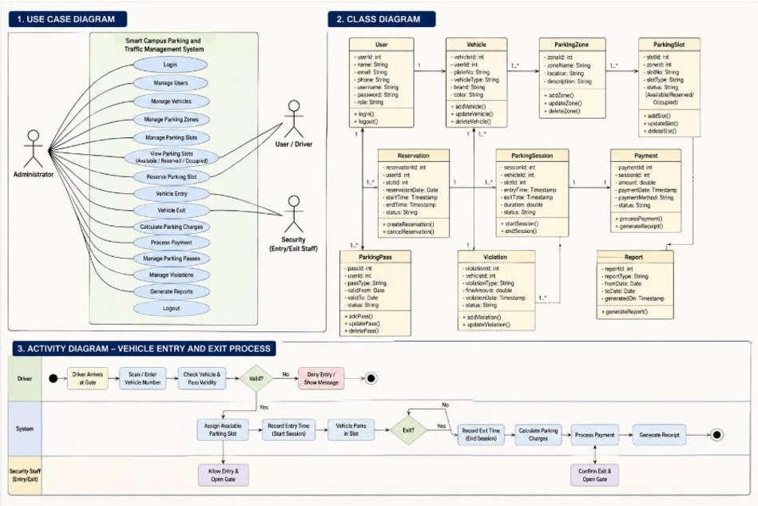

8. IMPLEMENTATION

8.1 Login Module
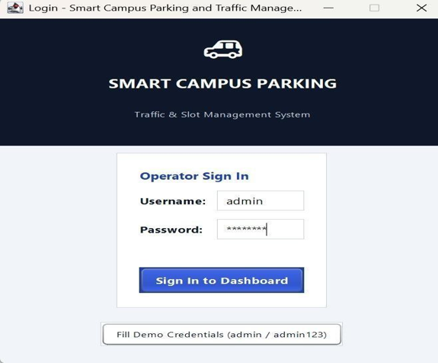
8.2 Dashboard Module
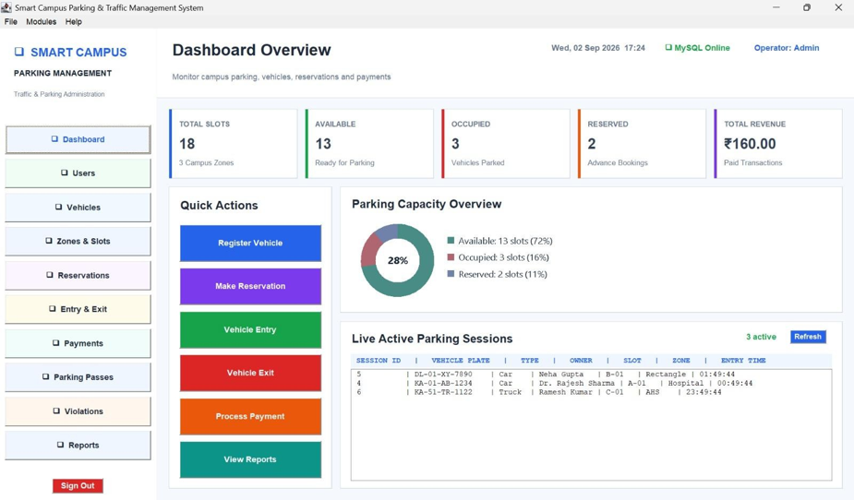
8.3 User Management
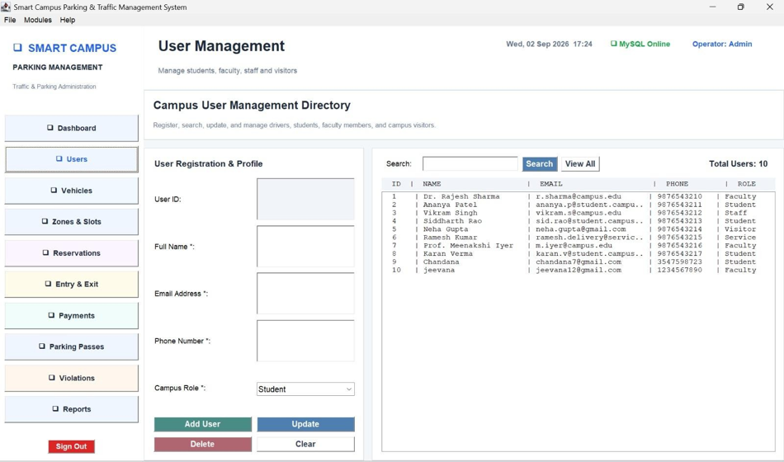

8.4 Vehicle Management
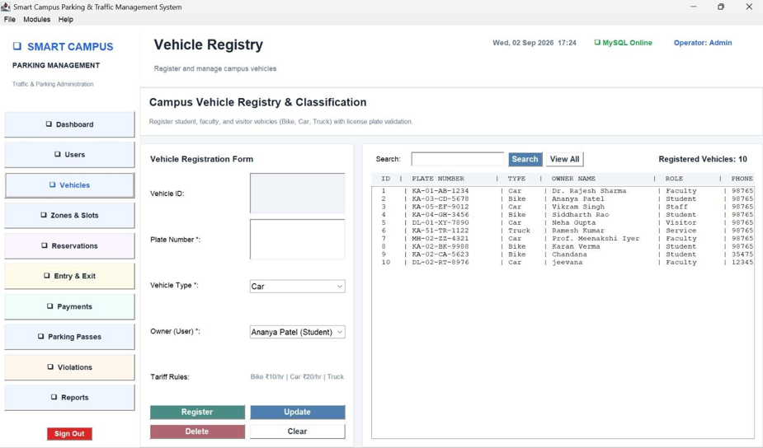

8.5 ZONES & PARKING SLOTS
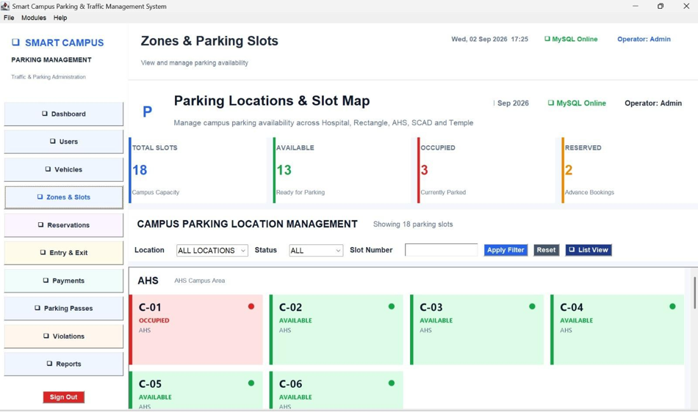

8.6 Parking Reservation
[Insert Parking Reservation screenshot here]

8.7 Gate Entry and Exit

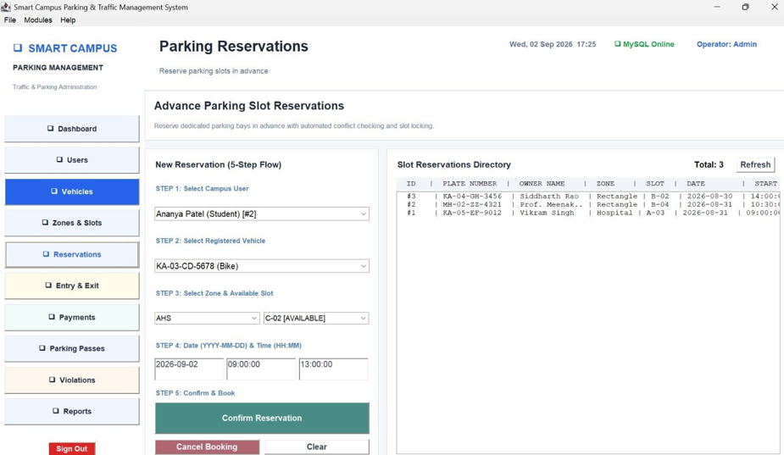8.8 Payment & Receipts

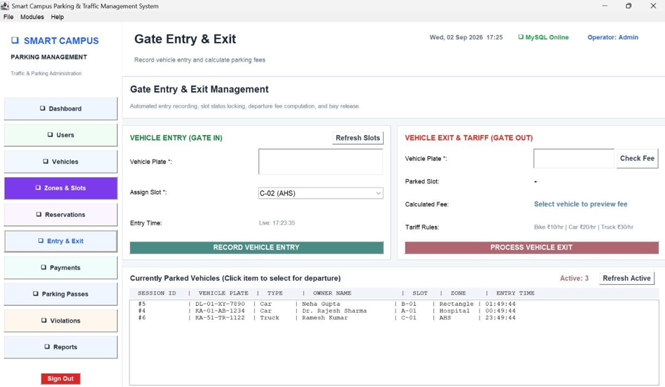8.9 Parking Pass

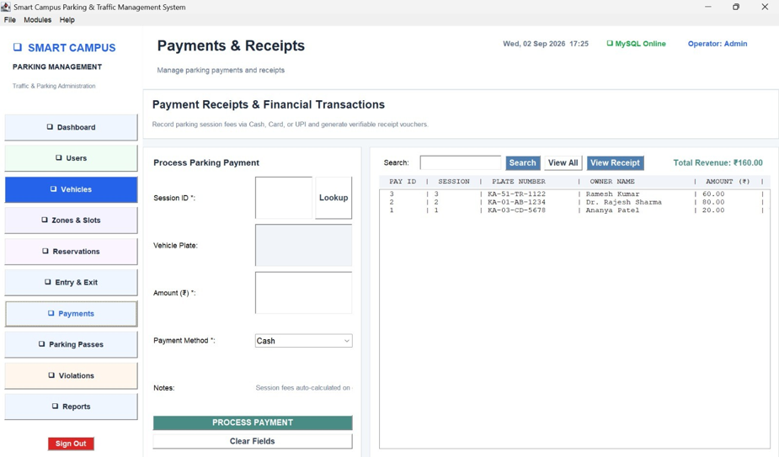8.10 Parking Violation

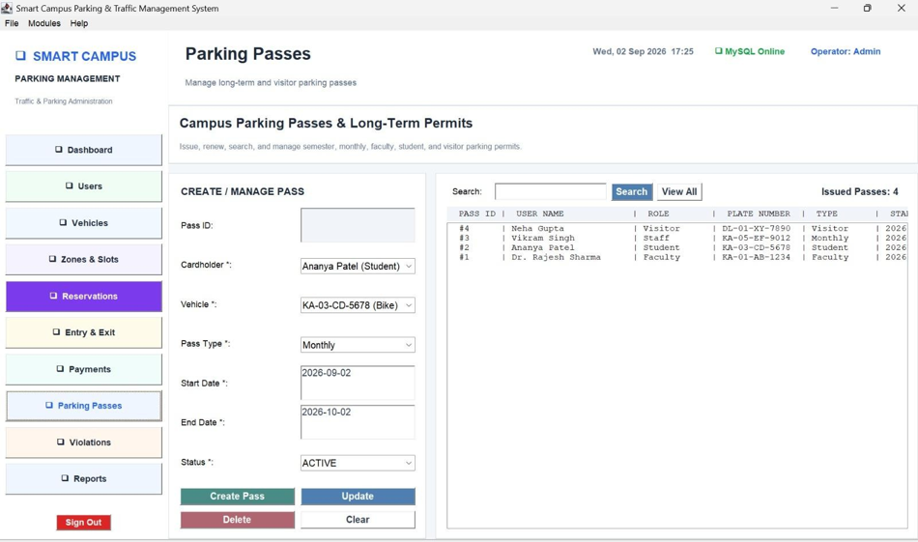8.11 Report & Analytics

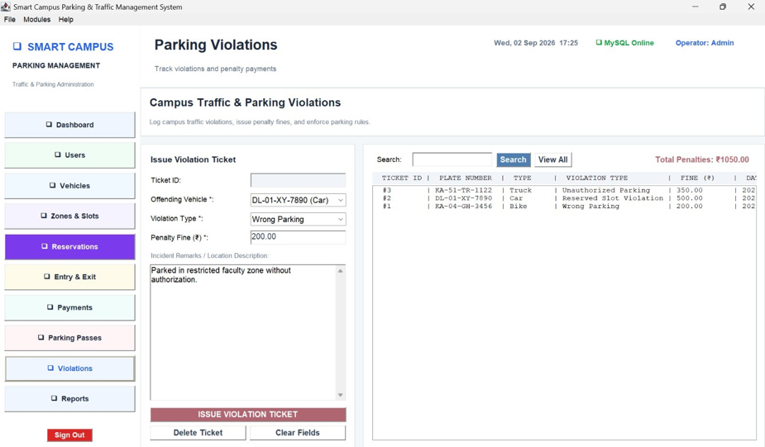9. JDBC IMPLEMENTATION

9.1 JDBC Connectivity
JDBC is used to connect the Java application with the MySQL database. A centralized database connection class is used to establish and manage database connections.

9.2 SQL Statement Types
The application demonstrates the required JDBC statement types:
JDBC Statement Type | Usage
Statement | General SQL queries
PreparedStatement | Parameterized INSERT, UPDATE, SELECT and DELETE operations
CallableStatement | Execution of the MySQL stored procedure
Mention your stored procedure:
get_total_revenue
This directly helps demonstrate CO5.

10. VALIDATION AND EXCEPTION HANDLING
Include:
- Duplicate vehicle validation
- Invalid vehicle details
- Unavailable parking slot
- Reserved slot checking
- Conflicting reservations
- Invalid entry information
- Invalid exit information
- Database connection errors
- SQL exceptions
- Empty-field validation

12. RESULTS
The Smart Campus Parking and Traffic Management System was successfully implemented using Java AWT/Swing and JDBC with MySQL. The application successfully provides user and vehicle management, parking zone and slot management, reservation, entry and exit tracking, fee calculation, payment processing, parking pass management, violation recording, and report generation.
The application was tested using different parking scenarios and the GUI operations were successfully connected with the MySQL database. The system correctly displays parking slot availability and maintains parking-related records.

13. CONCLUSION
The Smart Campus Parking and Traffic Management System provides an efficient computerized solution for managing university campus parking facilities. The integration of Java Swing/AWT and JDBC provides both an interactive graphical interface and reliable database operations.
The system reduces manual parking management by automating reservation, parking entry and exit, fee calculation, payment recording, parking pass management, violation tracking, and report generation. The project also demonstrates the practical application of event handling, GUI design, relational database concepts, SQL operations, and JDBC statement types.

14. INDIVIDUAL CONTRIBUTION

14.1 Member 1 Contribution
Worked on the GUI design and front-end development using Java Swing/AWT. Developed the login screen, dashboard, navigation menu, forms, buttons, tables, and parking-slot display. Also helped with testing and fixing GUI-related issues.

14.2 Member 2 Contribution
Worked on the MySQL database and JDBC connectivity. Created the required database tables and relationships and implemented INSERT, SELECT, UPDATE, and DELETE operations. Also worked with Statement, Prepared Statement, and Callable Statement.

